# ECE 162 Lab Report Template

Name: Brian Loughran (btl217@lehigh.edu)

## Purpose

In this lab we will measure current and resistance of a resistor attached to a 5V power source

## Theory

Ohm’s Law is very powerful, as it can give you theoretical values for current through any resistor, or voltage across any resistor. But sometimes it is nice to physically measure these values, either to see what the actual values are, or just to double check your calculations. In this lab, we will be measuring current and resistance of a 5.6 k Ω resistor attached to a 5V power source. Ohm’s law is listed below for reference:

V = I * R (eq. 1)

For this equation, V is voltage, measured in volts. I is current, measured in amperes. R is resistance, measured in Ω.

In this experiment there are two measurements. One is measurement of current passing through a resistor. For this measurement, the AVO must be set up in series with the resistor, and the power supply must be on to create a voltage drop. The second measurement is of resistance for the resistor, and for this the power supply cannot be on, otherwise it could damage the resistor. For this, the AVO supplies power in the system.

## Experimental Method

* Apply a voltage across a resistor and measure the current passing through
* Use the calculated current results (assuming a constant 5.0 V source) to calculate the resistance of the resistor
* Measure the resistance and compare it to the calculated value

## Diagram

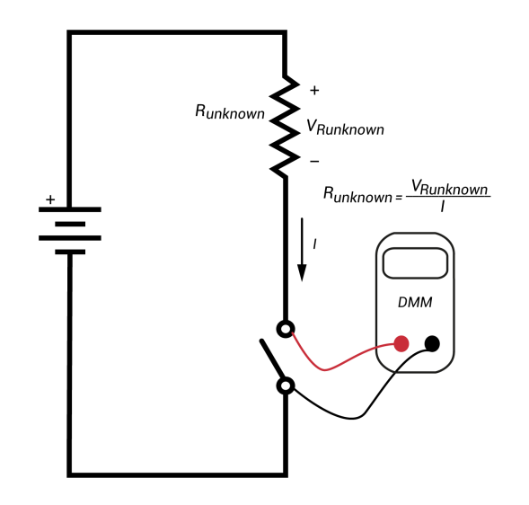For the first measurement, we want to calculate the current passing through the resistor. For this, the AVO should be connected in series with the resistor, and the power supply should be activated. This is shown in the diagram below:

## The second measurement to be taken is measurement of the resistance of a resistor. For this measurement, the voltage source should not be turned on. A diagram showing how to take the second measurement is shown below:

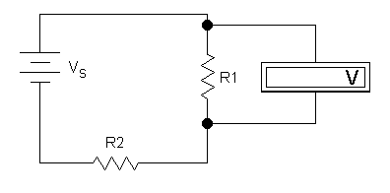

For this particular measurement, R2 can either be ignored or can be interpreted as the collective resistance of the wires and connections in the circuit. Regardless, it does not affect the measurement of R1.

## Results

The resistor chosen for this experiment was listed as a 5600 Ω resistor. After applying 5V across the resistor, the theoretical values for resistance, current and voltage would be as follows:

|  |  |  |
| --- | --- | --- |
| Resistance (Ω) | Current (mA) | Voltage (V) |
| 5600 | .893 | 5 |

Measurement of the actual current through the resistor indicated that the real-world current was slightly different from the theoretical value. Using this value for current, a new resistance value was calculated, and the values for resistance, current and voltage are show below (assuming a perfect 5.0V source):

|  |  |  |
| --- | --- | --- |
| Resistance (Ω) | Current (mA) | Voltage (V) |
| 5695 | .878 | 5 |

The actual resistance of the resistor was measured, and the results are shown below. The voltage was calculated as a product of the resistance and current.

|  |  |  |
| --- | --- | --- |
| Resistance (Ω) | Current (mA) | Voltage (V) |
| 5574 | .878 | 4.89 |

Throughout the experiment, the resistance of the resistor varied only 2.1%.

## Discussion

This lab was very useful in practicing resistance and current measurement, as well as the basics of building circuits. While the results of the experiment are not particularly interesting or surprising, learning the method of how to set up circuits and measure key values in the circuit is an important skill to have.

## Conclusion

This simple experiment further proved Ohm’s Law as a powerful tool to compare voltage and current. It also provided invaluable experience in methods to measure voltage, current and resistance.